Task — 10 Marks

Sign in to the AWS Account:

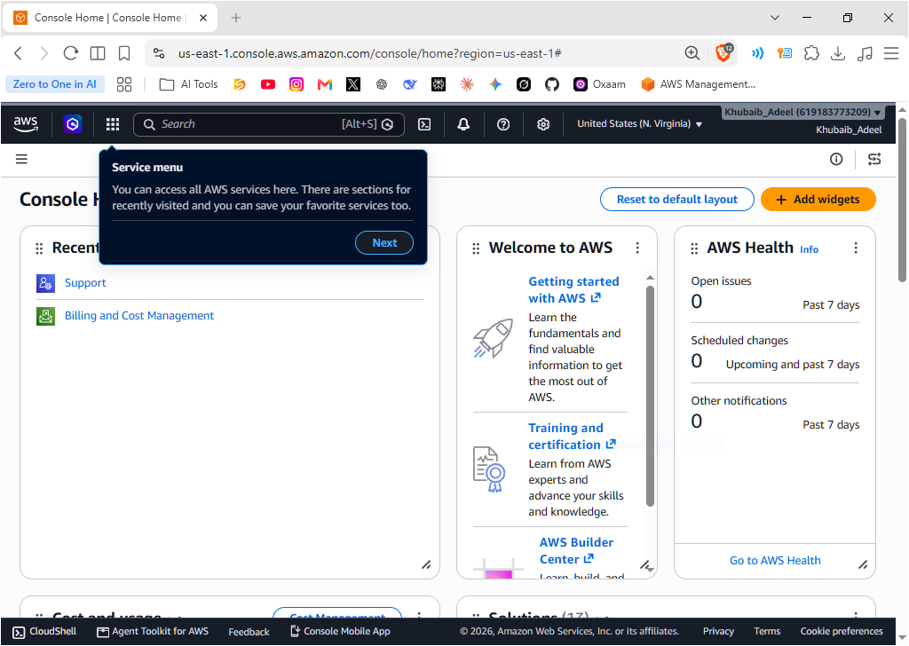

Navigate to the S3 Service:
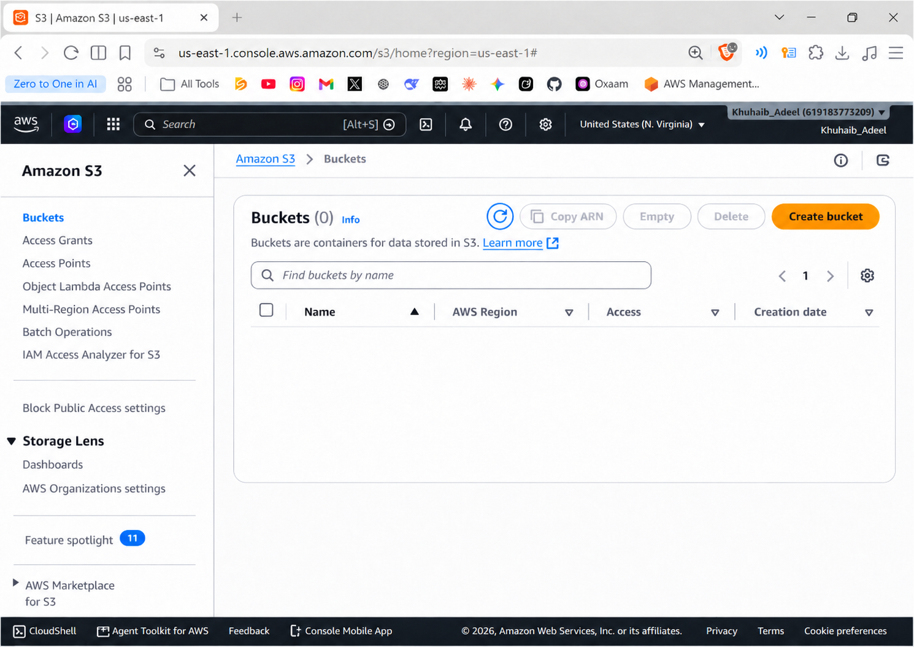

- Click on Create Bucket:
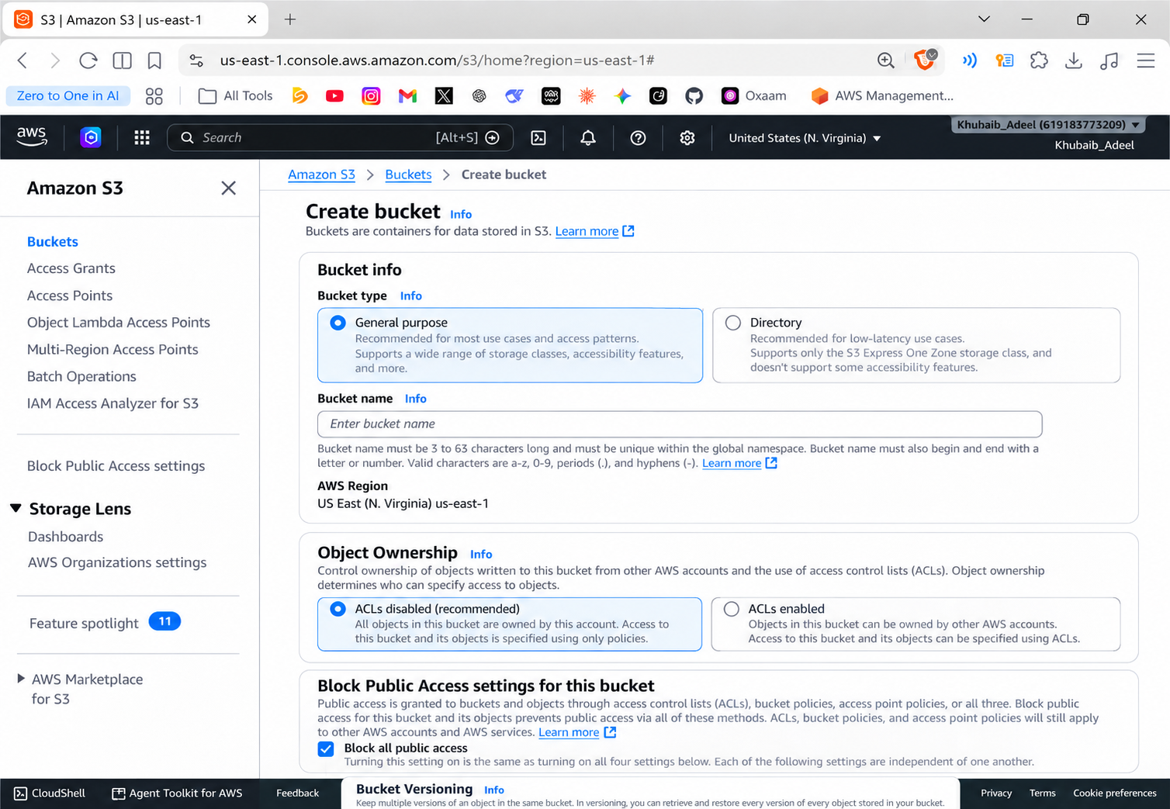

- Enter a unique bucket name (e.g., my-first-bucket-yourname-2026):
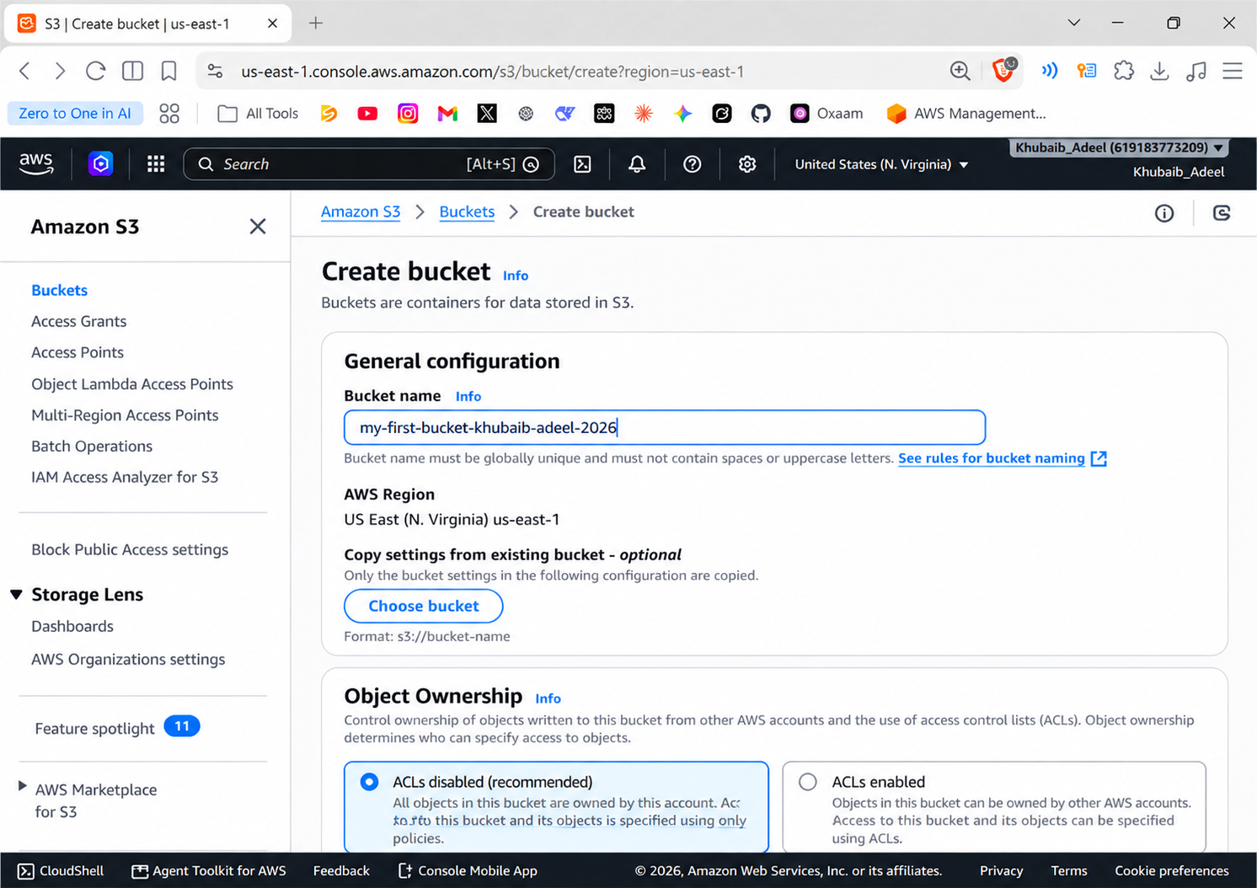

- Keep the AWS Region as Default:
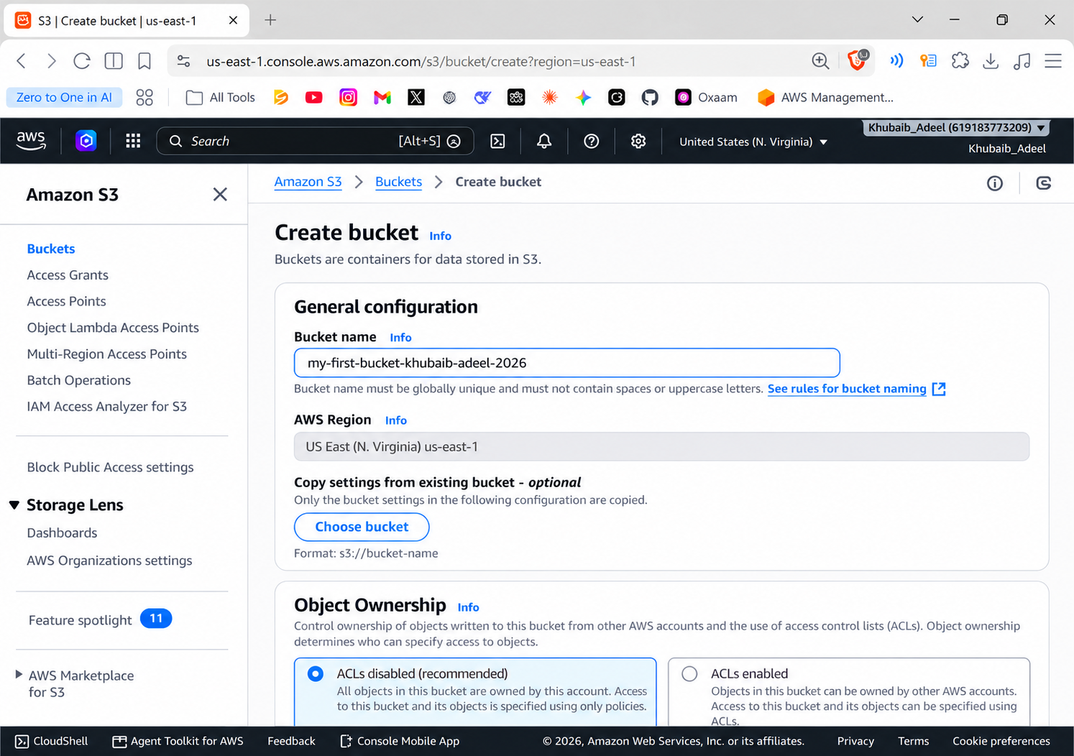

- Leave Object Ownership and Block Public Access settings as default for now:
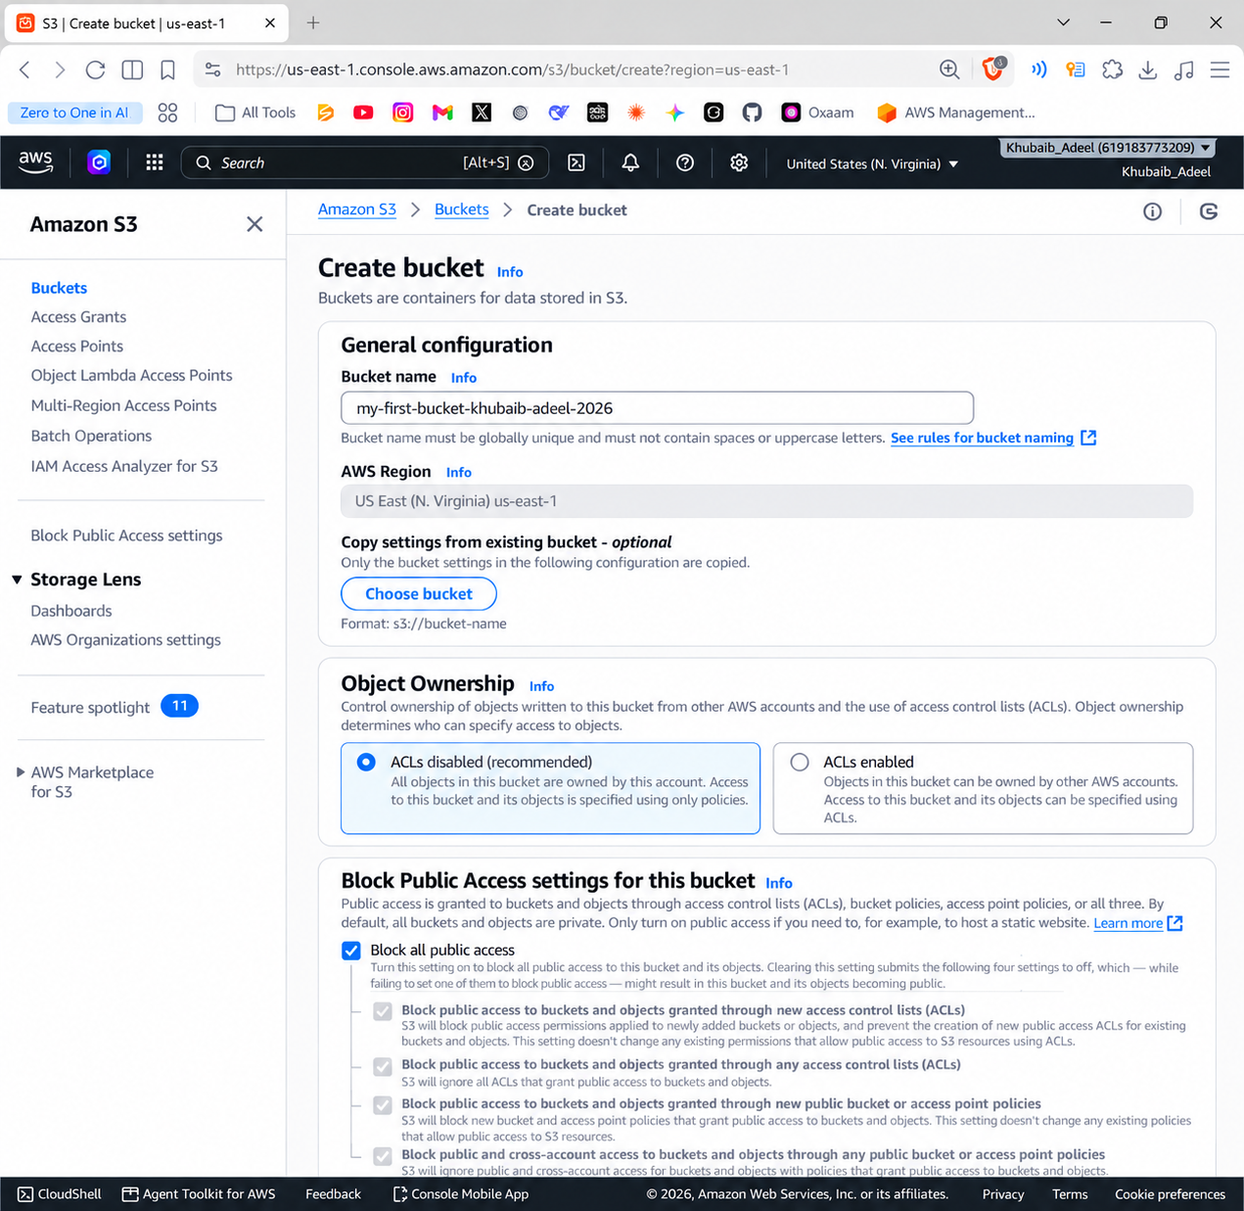
- Keep all other settings as default and click Create bucket:
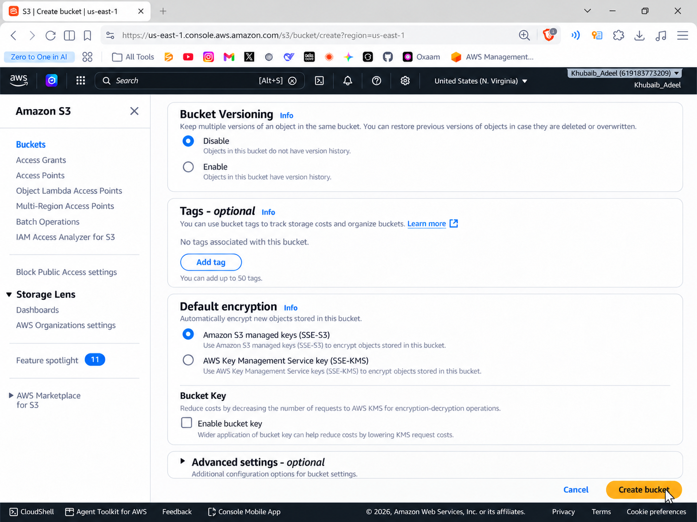
- Keep all other settings as default and click Create bucket:
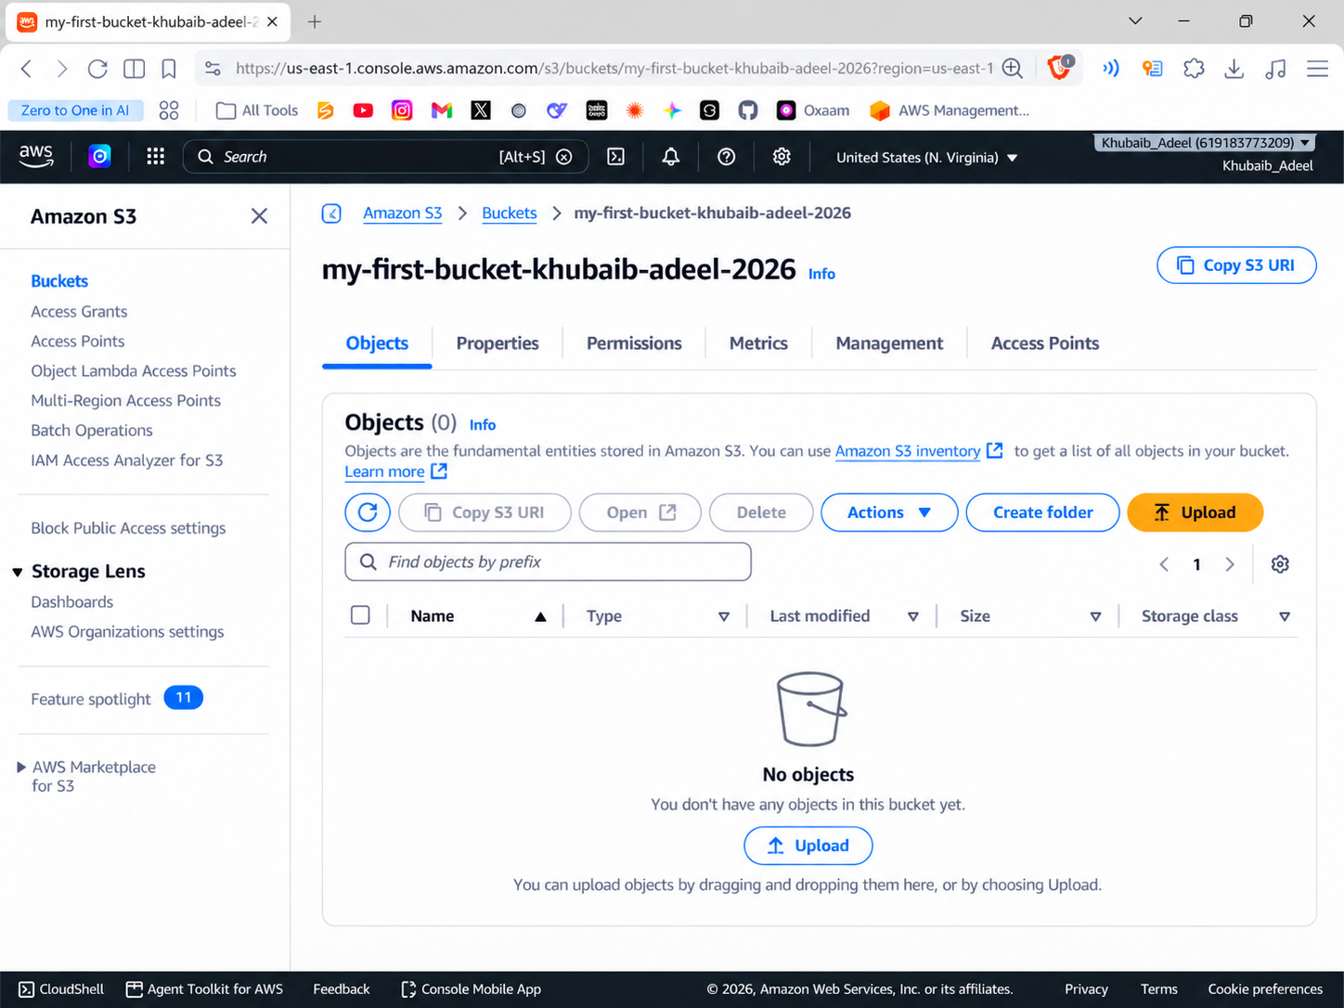
- Click Upload and upload any simple file:
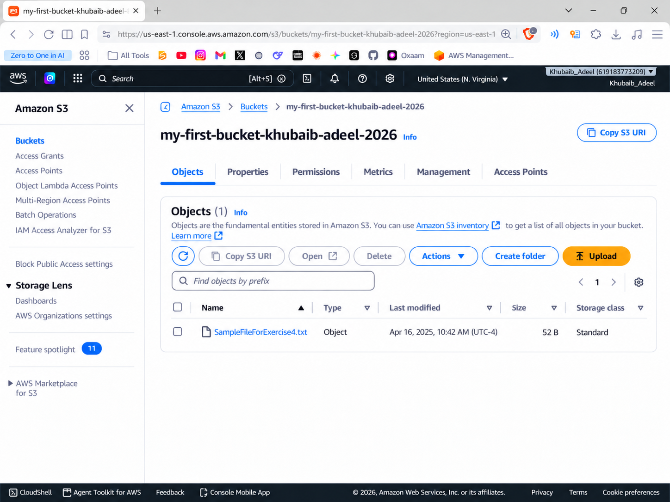
- Click Upload and upload any simple file:
